

**Placement Empowerment Program**

***Cloud Computing and DevOps Centre***

**Use Cloud Storage**: Create a storage bucket on your cloud platform and upload/download files. Configure access permissions for the bucket.

**Name: Sri Pooja K A Department: CSE**

**Introduction**

In this (PoC), we will explore AWS S3 (Simple Storage Service) to understand its functionality as a reliable cloud storage solution. The task involves creating an S3 bucket, uploading and downloading files, and configuring access permissions to manage who can access the stored data. This PoC demonstrates S3's versatility in securely storing and retrieving files, both publicly and privately. We will also set bucket policies to control access and test public URLs for hosted files. By completing this task, we gain hands-on experience with S3 and its key features, such as scalability, security, and cost-efficiency.

**Objectives**

* Understand AWS S3 Basics: Learn how to create, configure, and manage an S3 bucket for cloud storage.
* File Operations: Gain hands-on experience in uploading, downloading, and managing files within the S3 bucket.
* Access Control: Configure bucket policies and permissions to manage secure and public access to stored data.

**Step by Step Overview**

**1. Create a S3 Bucket**

* Log in to your management console.
* Navigate into S3.
* Block public access.

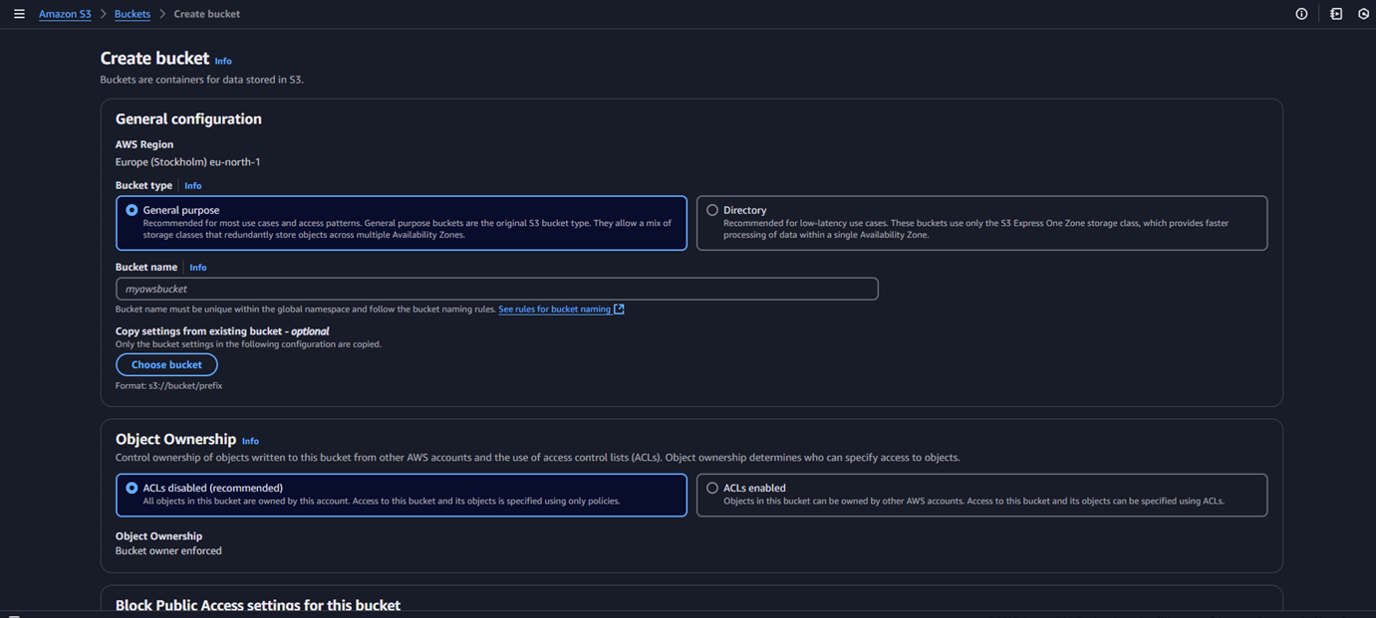

**2. Upload into bucket**

* Now, after creating the bucket. Open it and Click on Upload option.
* Choose a image into upload.
* Go to the uploaded file in your bucket. Click the file name to open its details. Select Download to save the file locally.

### **3. Permissions**

* Open your Bucket and navigate to “Permissions” tab.
* Click on “Block Public Access”.

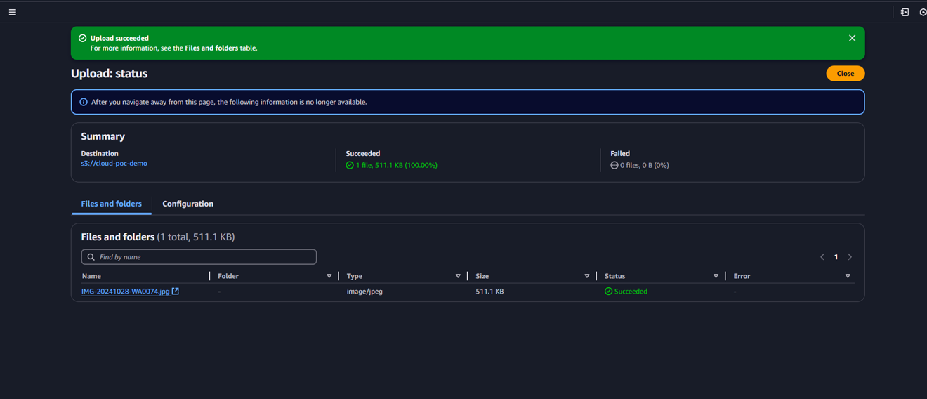

**4. Accessing the uploaded image**

Use the S3 bucket URL or public file URL to test access permissions.

**Outcome:**

We have successfully create an AWS S3 bucket and perform file upload/download operations. And configured and validate access permissions, ensuring secure or public access as needed. And gained a solid understanding of S3's functionality, enabling its use in real world cloud-based applications.